Name: _____________________________________ Period: _____________ Date: __________________
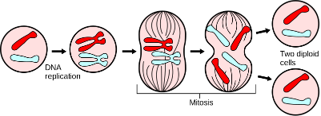
SC.7.L.16.3
The Story of Our Start
Essential Question: Compare asexual and sexual reproduction.
Practice 1: Which of the following describes asexual reproduction?
- Passing an identical set of genes to the offspring
- Sorting only the best genes to pass on to the offspring
- Passing unique sets of genes to the offspring
- Engineering new sets of genes for the offspring

Practice 2: Circle all the organisms that can reproduce asexually.
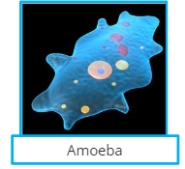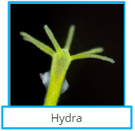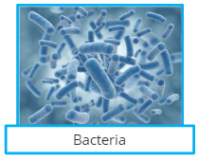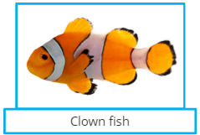

Practice 3: Place the letters that represent the terms in the correct category below.

- Genetically identical offspring
- Two Parents
- One Parent
- Genetically unique offspring
- Produce offspring

Asexual Reproduction | Asexual and Sexual Reproduction | Sexual Reproduction

Practice 4: Which of the following best describe the process of mitosis?
- Process that combines two cells to create two diploid daughter cells
- Process creating two identical diploid daughter cells
- Process of creating one similar haploid daughter cell

Practice 5: A parent has 10 chromosomes. How many chromosomes would each daughter cell contain that were created through meiosis?
- 5 chromosomes
- 10 chromosomes
- 20 chromosomes
- 7 chromosomes

Practice 6: Which of these processes describe meiosis?
- A process in which DNA is replicated from one parent cell into two diploid daughter cells
- A process in which DNA is sorted by age to pass on to two haploid daughter cells
- A process in which DNA is combined by two parents into four daughter cells
- A process in which a parent cell divides into four haploid daughter cells

Practice 7: Place the letters that represent the descriptions in the correct category below.
- Related to asexual reproduction
- Passes along genetic material
- Creates 4 haploid daughter cells in total
- Creates 2 diploid daughter cells in total
- Creates unique sets of DNA
- Passes exact DNA set from parent to daughter cell
- Related to sexual reproduction
Mitosis | Both | Meiosis

Essential Question: Compare asexual and sexual reproduction.
________________________________________________________________________________________________________________________________________________________________________________________________________________________________________________________________________________________________________________________________________________________________________________________________________________________________________________________________________________________________

